CSE 581

**Lab 10: Data Manipulation**

*Do this against YOUR own database.*

***For the entire lab, provide all of your SQL as text, inserted at the beginning of the document.***

***For each step also provide a screenshot of execution, showing the SQL and the results.***

***Please make sure both the SQL and the screenshots are marked w/ the question number that they are answering.***

**Steps:**

1. Insert the following data into the tables. Make sure that the data matches perfectly!

***USERS:***

|  |  |  |  |  |  |
| --- | --- | --- | --- | --- | --- |
| **NTID** | **FirstName** | **MiddleInitial** | **LastName** | **EmailAddress** | **Password** |
| 01-HJPotter | Harry | J | Potter | [hp@hw.edu](mailto:hp@syu.edu) | Hedwig |
| 02-RBWeasley | Ron | H | Weasley | [rw@hw.edu](mailto:rw@syu.edu) | Scabbers |
| 03-HJGranger | Hermione | B | Granger | [hg@hw.edu](mailto:hg@syu.edu) | Crookshanks |
| 10-Rlupin | Remus | <NULL> | Lupin | [rl@hw.edu](mailto:rl@syu.edu) | moon |
| 11-Fflitwick | Filius | <NULL> | Flitwick | [ff@hw.edu](mailto:ff@hg.edu) | <NULL> |
| 16-Rhagrid | Rubeus | <NULL> | Hagrid | [rh@hw.edu](mailto:rh@syu.edu) | BuckBeak |

INSERT INTO Users (NTId, FirstName, MiddleInitial, LastName, EmailAddress, Password)

VALUES ('01-HJPotter' , 'Harry' , 'J', 'Potter' , 'hp@hw.edu' , 'Hedwig'),

('02-RBWeasley', 'Ron' , 'H', 'Weasley' , 'rw@hw.edu' , 'Scabbers'),

('03-HJGranger','Hermione', 'B', 'Granger' , 'hg@hw.edu' , 'Crookshanks'),

('10-Rlupin' ,'Remus' , NULL, 'Lupin' , 'rl@hw.edu' , 'moon'),

('11-Fflitwick','Filius' , NULL, 'Flitwick', 'ff@hw.edu' , NULL),

('16-Rhagrid' ,'Rubeus' , NULL, 'Hagrid' , 'rh@hw.edu' , 'BuckBeak');

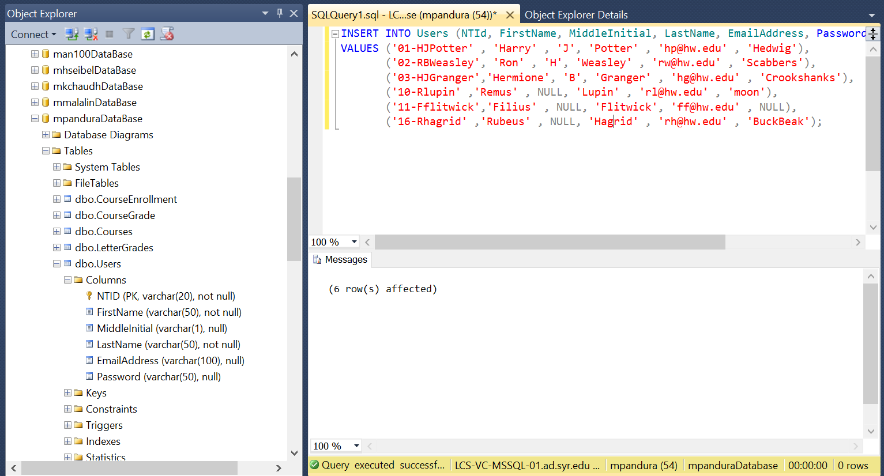

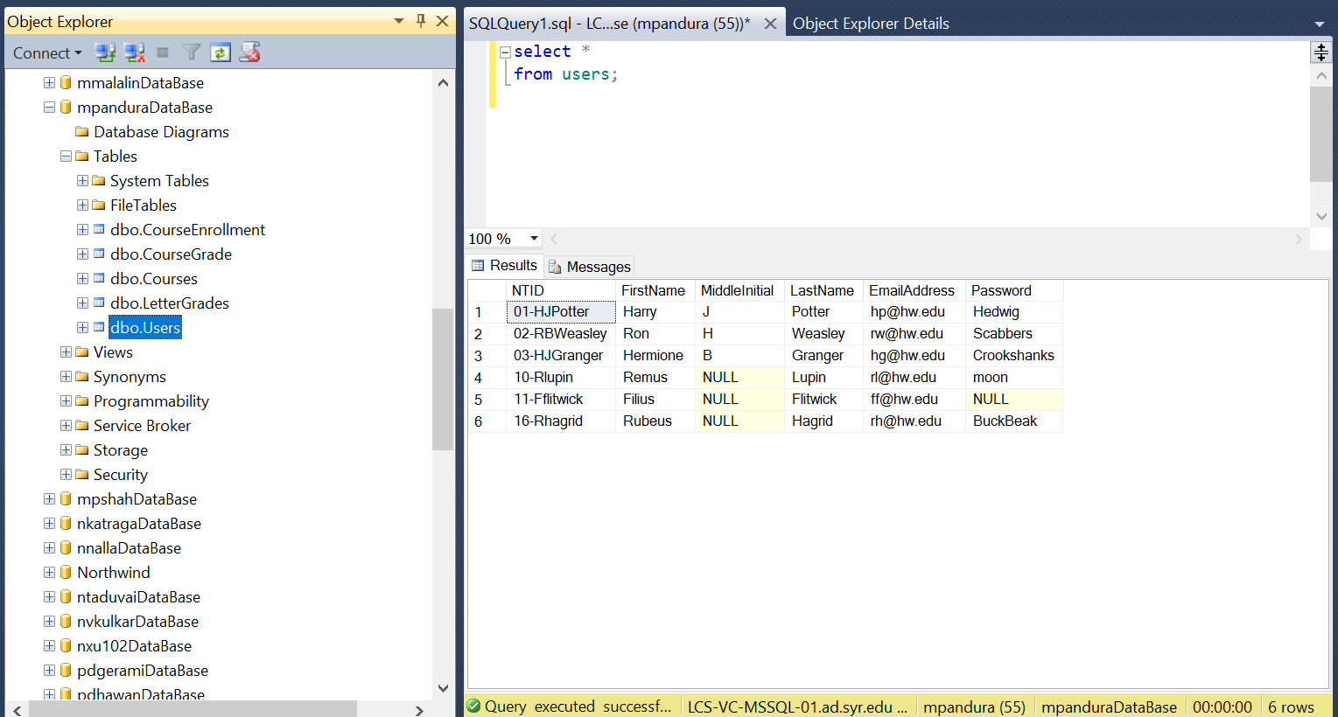

***COURSES:***

|  |  |  |  |  |
| --- | --- | --- | --- | --- |
| **CourseID** | **CourseCode** | **CourseTitle** | **Faculty** | **OpenSeats** |
| 1 | DADA101 | Defence Against the Dark Arts BASIC | 10-Rlupin | 3 |
| 2 | DADA201 | Defence Against the Dark Arts INTERMEDIATE | 10-Rlupin | 2 |
| 3 | DADA301 | Defence Against the Dark Arts ADVANCED | 10-Rlupin | 1 |
| 4 | CHMS101 | Charms BASIC | 11-Fflitwick | 2 |
| 5 | CHMS201 | Charms INTERMEDIATE | 11-Fflitwick | 0 |
| 6 | CHMS301 | Charms ADVANCED | 11-Fflitwick | 4 |
| 7 | HOM101 | History of Magic BASIC | <NULL> | 10 |

INSERT INTO Courses(CourseCode, CourseTitle,Faculty,OpenSeats )

VALUES ('DADA101', 'Defence Against the Dark Arts BASIC' ,'10-Rlupin' , 3),

('DADA201', 'Defence Against the Dark Arts INTERMEDIATE' ,'10-Rlupin' , 2),

('DADA301', 'Defence Against the Dark Arts ADVANCED' ,'10-Rlupin' , 1),

('CHMS101', 'Charms BASIC' ,'11-Fflitwick' , 2),

('CHMS201', 'Charms INTERMEDIATE' ,'11-Fflitwick' , 0),

('CHMS301', 'Charms ADVANCED' ,'11-Fflitwick' , 4),

('HOM101', 'History of Magic BASIC' , NULL , 10);

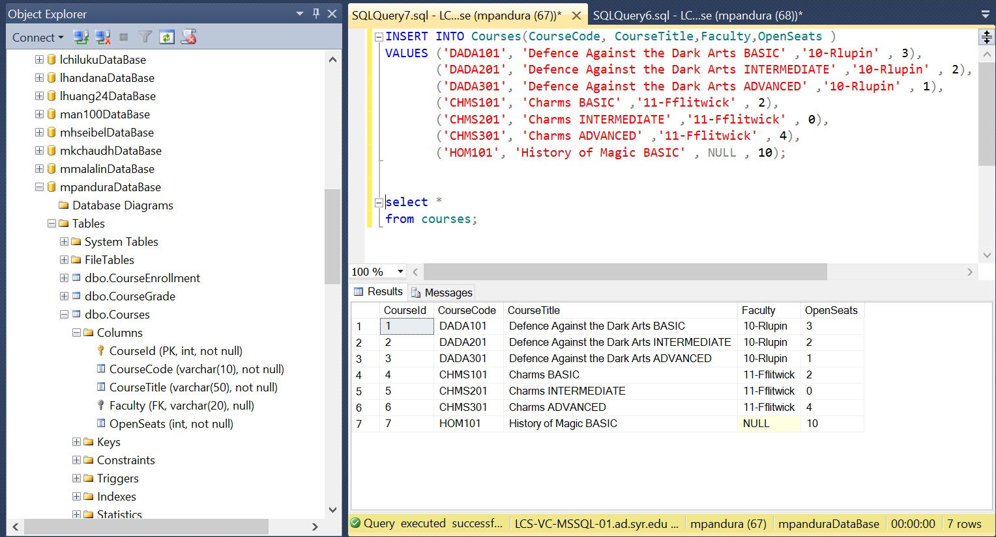

***NEXT PAGE***

***LETTER GRADES:***

|  |  |  |
| --- | --- | --- |
| **LetterGradeID** | **LetterGrade** | **Description** |
| 1 | O | Outstanding |
| 2 | E | Exceeds Expectations |
| 3 | A | Acceptable |
| 4 | P | Poor |
| 5 | D | Dreadful |
| 6 | T | Troll |

INSERT INTO LetterGrades ( LetterGrade, Description )

VALUES ('O' , 'Outstanding'),

('E' , 'Exceeds Expectations'),

('A' , 'Acceptable'),

('P' , 'Poor'),

('D' , 'Dreadful'),

('T' , 'Troll');

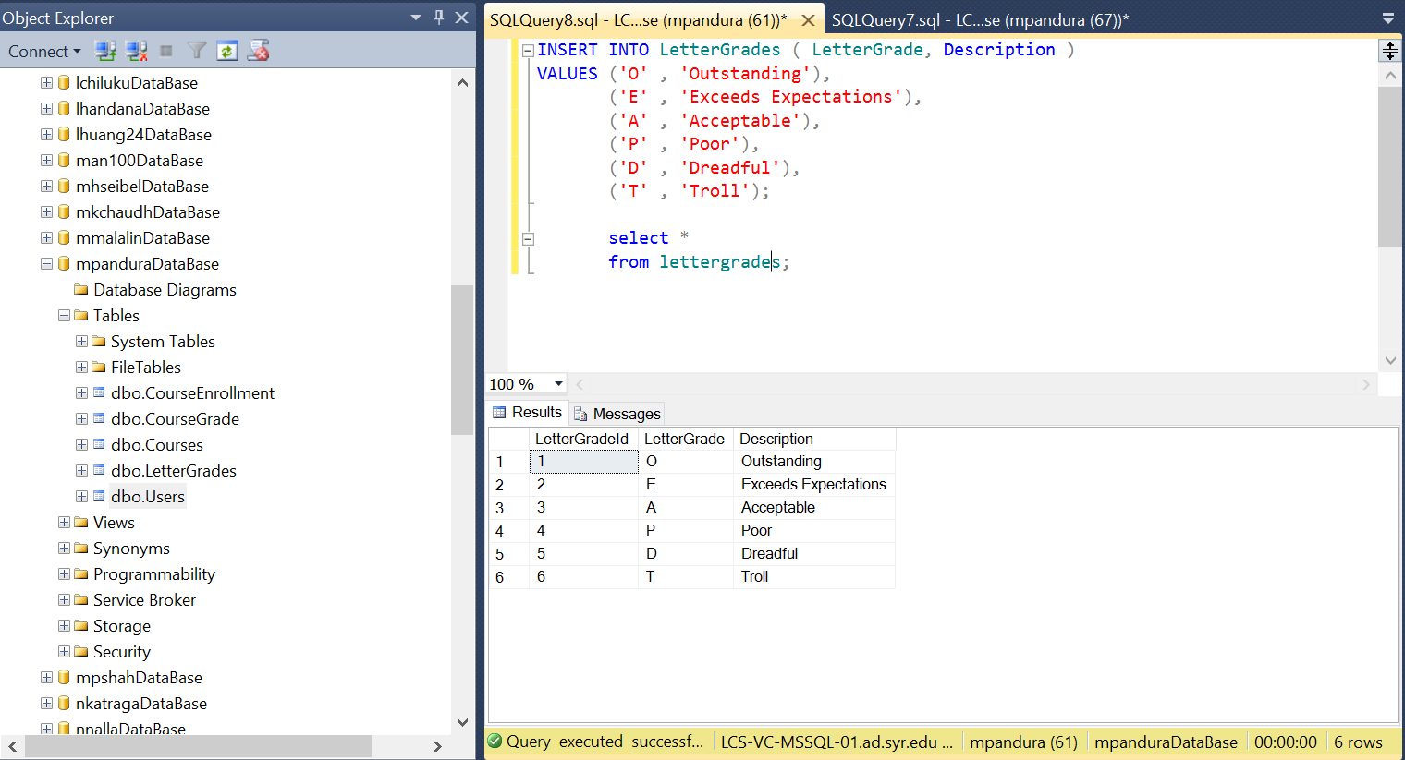

***COURSE GRADING:***

|  |  |  |  |
| --- | --- | --- | --- |
| **GradingScaleID** | **LetterGradeID** | **CourseID** | **GradeValue** |
| 1 | 1 | 1 | 95 |
| 2 | 2 | 1 | 90 |
| 3 | 3 | 1 | 80 |
| 4 | 4 | 1 | 70 |
| 5 | 5 | 1 | 60 |
| 6 | 6 | 1 | 0 |
| 7 | 1 | 2 | 100 |
| 8 | 2 | 2 | 90 |
| 9 | 3 | 2 | 85 |
| 10 | 4 | 2 | 75 |
| 11 | 5 | 2 | 64 |
| 12 | 6 | 2 | 0 |

INSERT INTO CourseGrade (LetterGradeId,CourseID,GradeValue)

VALUES (1,1,95),

(2,1,90),

(3,1,80),

(4,1,70),

(5,1,60),

(6,1,0),

(1,2,100),

(2,2,90),

(3,2,85),

(4,2,75),

(5,2,64),

(6,2,0);

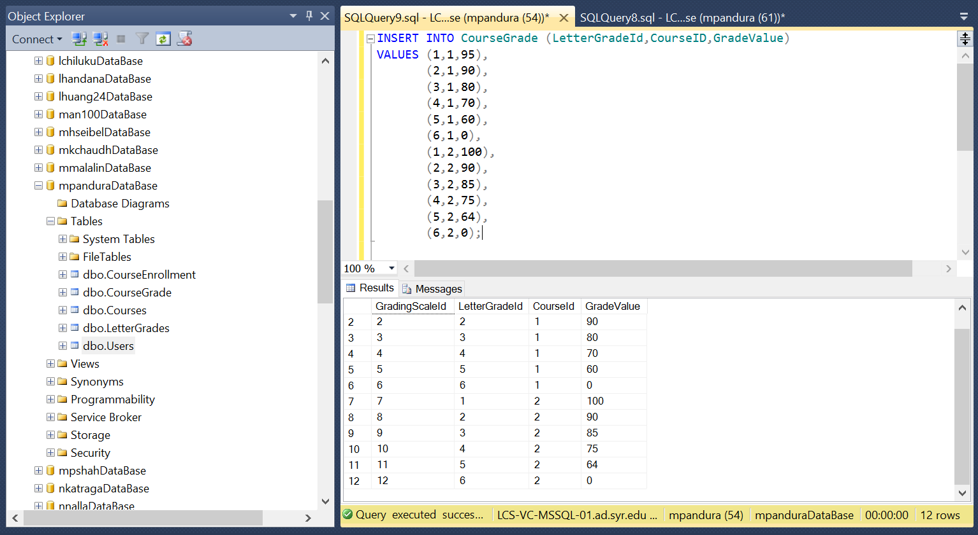

***COURSE ENROLLMENT:***

|  |  |  |  |
| --- | --- | --- | --- |
| **EnrollmentID** | **StudentId** | **CourseID** | **FinalGrade** |
| 1 | 01-HJPotter | 1 | <NULL> |
| 2 | 01-HJPotter | 4 | <NULL> |
| 3 | 03-HJGranger | 1 | <NULL> |
| 4 | 03-HJGranger | 4 | <NULL> |
| 5 | 02-RBWeasley | 1 | <NULL> |
| 6 | 02-RBWeasley | 4 | <NULL> |

INSERT INTO CourseEnrollment (StudentId,CourseID, FinalGrade)

VALUES ('01-HJPotter', 1, NULL),

('01-HJPotter', 4, NULL),

('03-HJGranger', 1, NULL),

('03-HJGranger', 4, NULL),

('02-RBWeasley', 1, NULL),

('02-RBWeasley', 4, NULL);

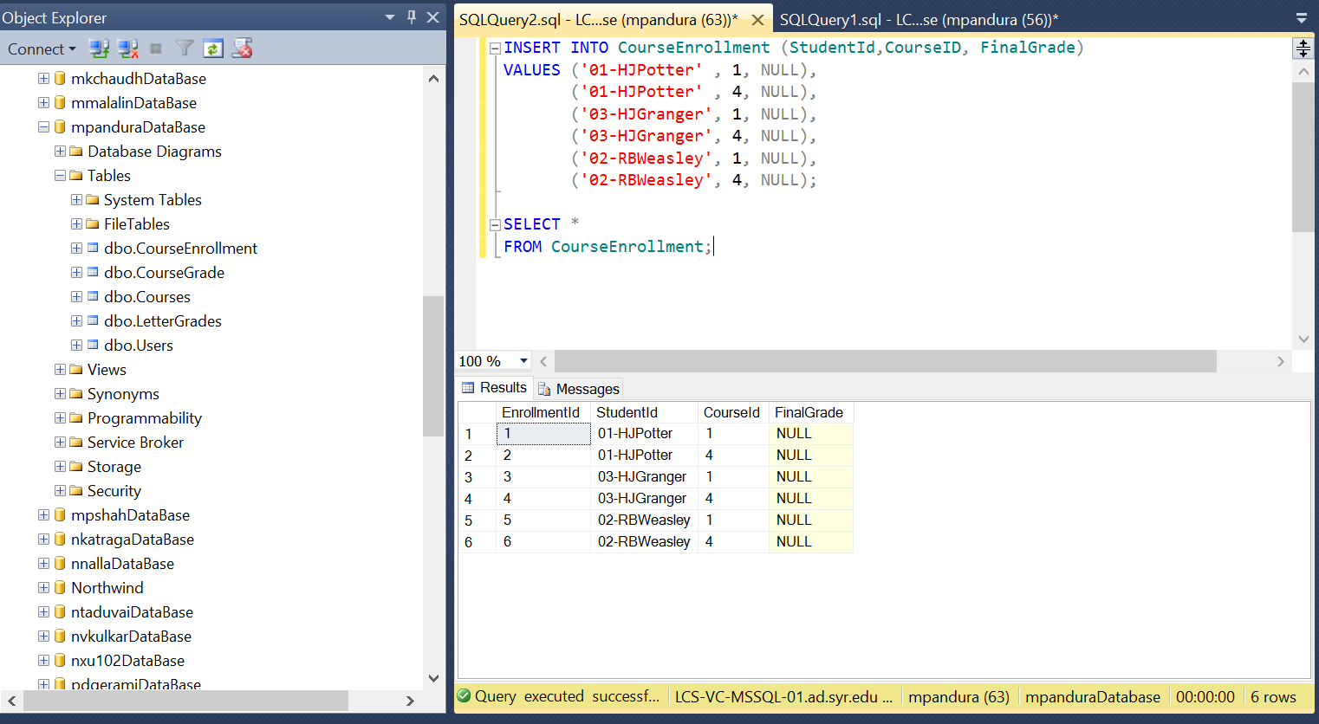

***NEXT PAGE***

1. Make the following updates (use INSERT, UPDATE and DELETE, as needed):
2. Lupin has been fired. Assign his classes to Hagrid. Remove Lupin from the database.

UPDATE Courses

SET Faculty = '16-Rhagrid'

WHERE Faculty ='10-Rlupin';

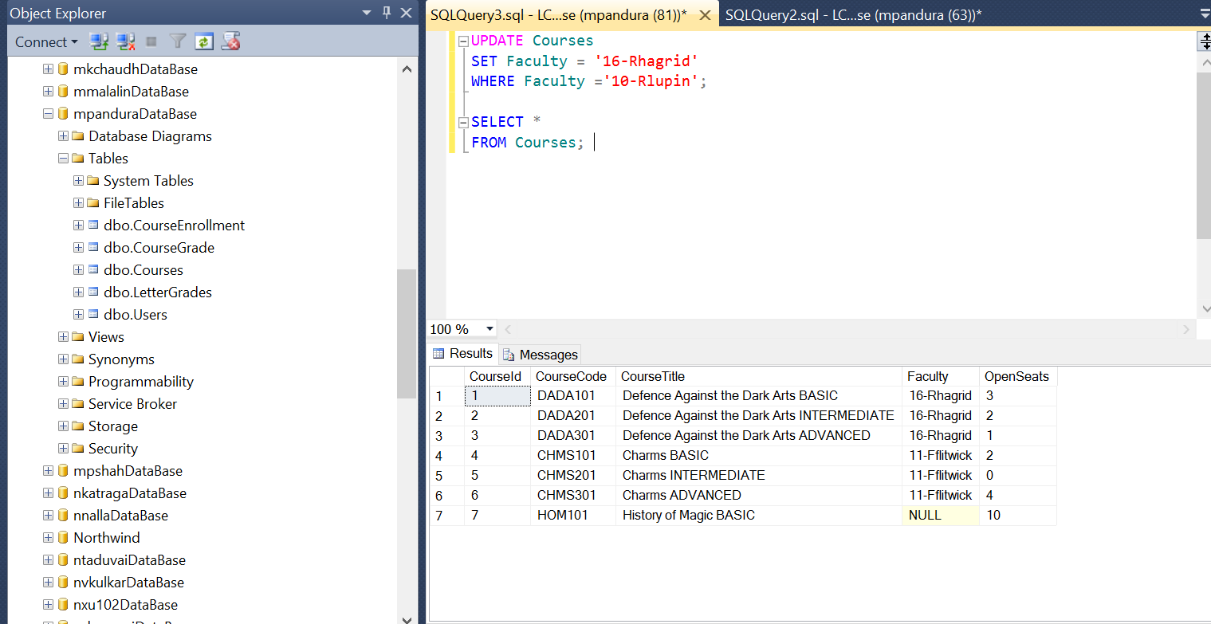

DELETE FROM Users

WHERE LastName = 'Lupin';

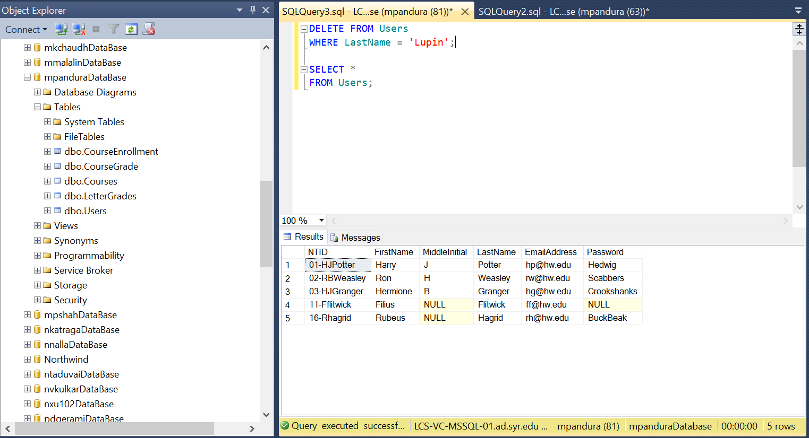

1. Harry has received a final grade of 96 in Defence Against the Dark Arts, and 91 in Charms.

UPDATE CourseEnrollment

SET FinalGrade = 96.00

WHERE StudentId ='01-HJPotter' AND CourseID = 1;

UPDATE CourseEnrollment

SET FinalGrade = 91.00

WHERE StudentId ='01-HJPotter' AND CourseID = 4;

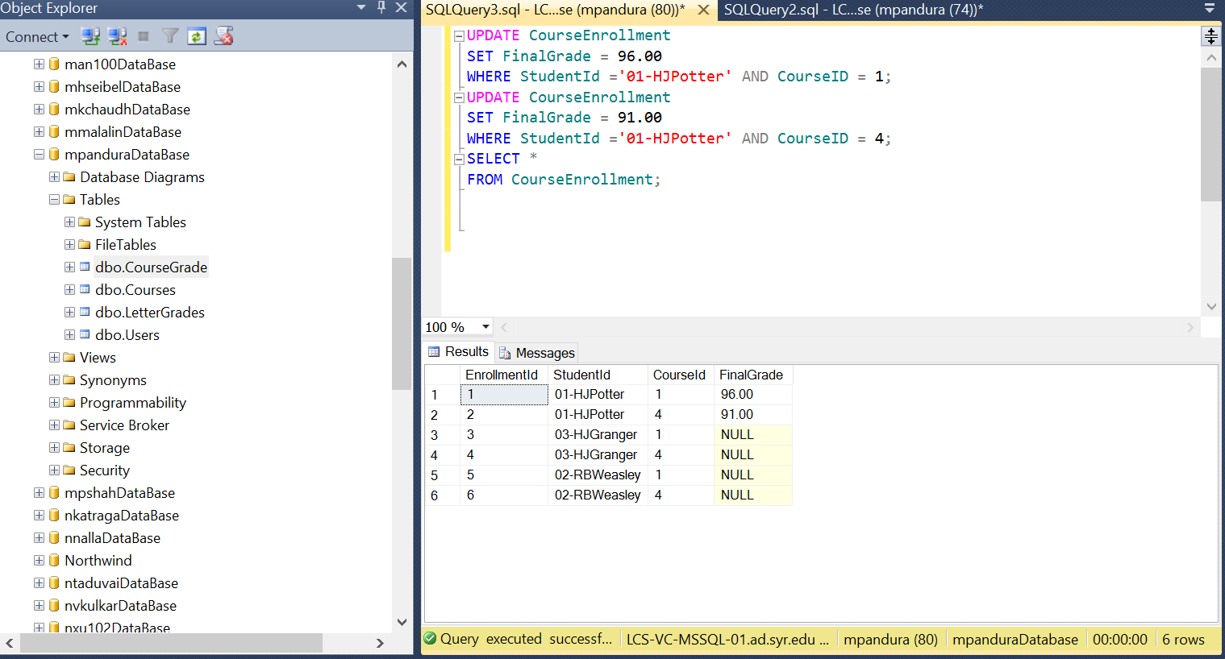

1. Ron has received a final grade of 91 in Defence Against the Dark Arts, and 88 in Charms.

UPDATE CourseEnrollment

SET FinalGrade= 91.00

WHERE StudentId ='02-RBWeasley' AND CourseID = 1;

UPDATE CourseEnrollment

SET FinalGrade= 88.00

WHERE StudentId ='02-RBWeasley' AND CourseID = 4;

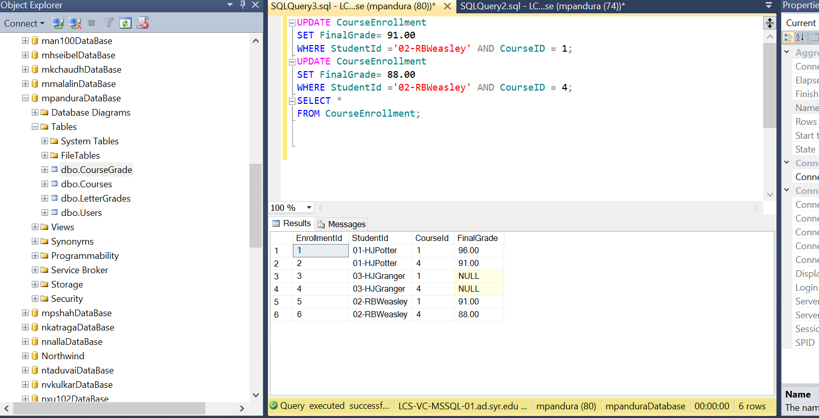

1. Hermione has received a final grade of 92.22 in Defence Against the Dark Arts, and 99 in Charms.

UPDATE CourseEnrollment

SET FinalGrade= 92.22

WHERE StudentId ='03-HJGranger' AND CourseID = 1;

UPDATE CourseEnrollment

SET FinalGrade= 99.00

WHERE StudentId ='03-HJGranger' AND CourseID = 4;

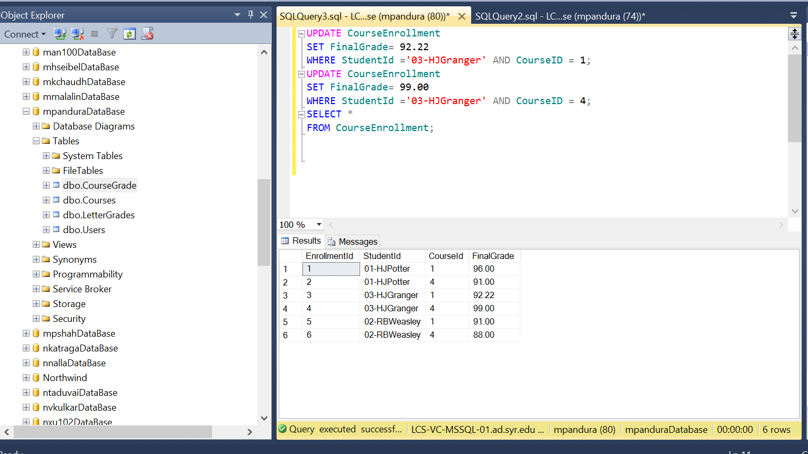

1. Enroll Harry in Intermediate Defence Against the Dark Arts.

INSERT INTO CourseEnrollment(StudentId,CourseID, FinalGrade)

VALUES ('01-HJPotter', 2, NULL);

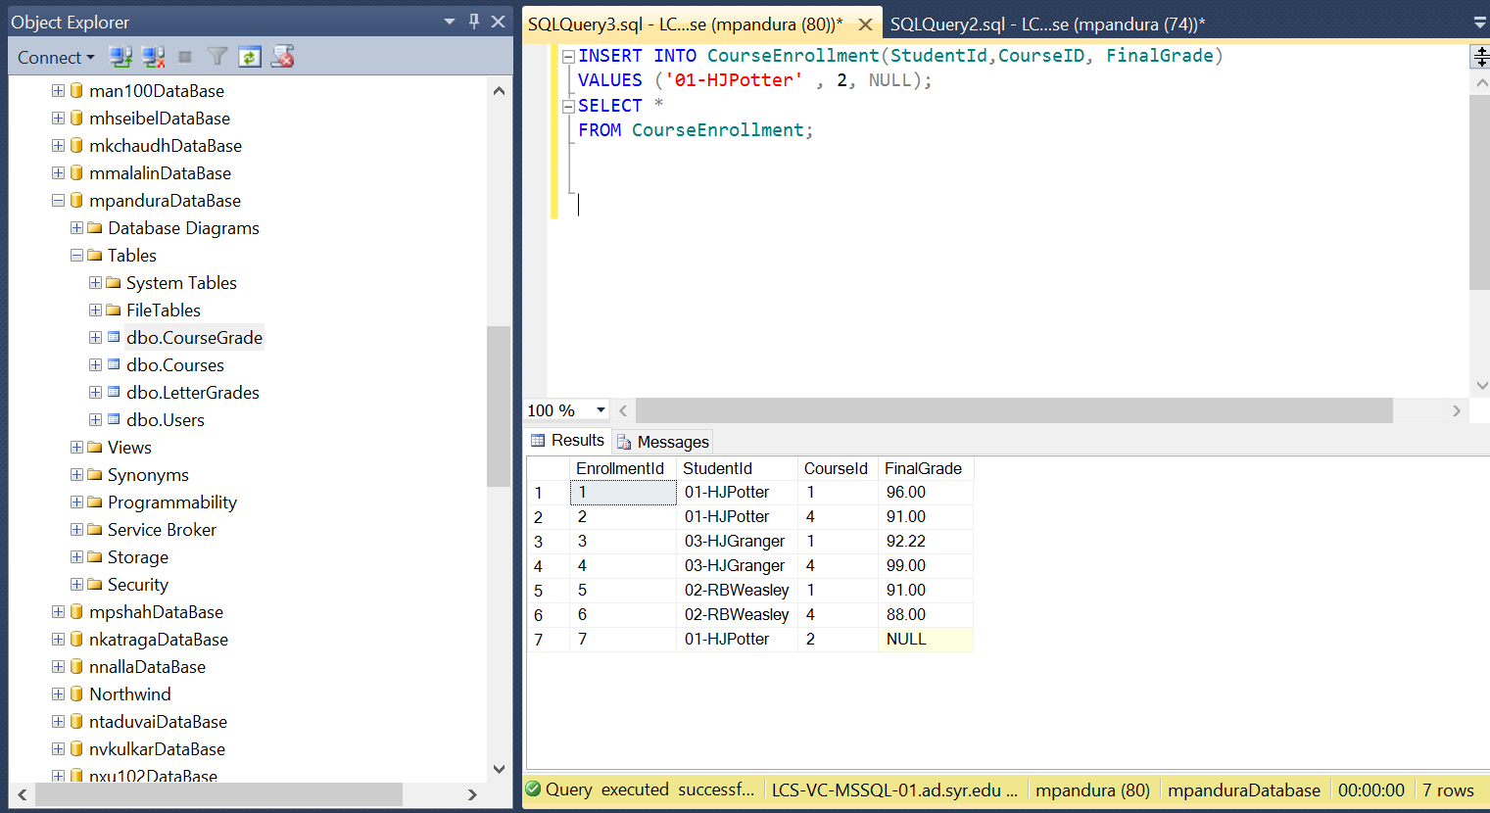

1. Enroll Hermione in Advanced Charms.

INSERT INTO CourseEnrollment(StudentId,CourseID, FinalGrade)

VALUES('03-HJGranger', 6, NULL);

